Research Management System (RMS) Replacement

Project Charter Document

Doc. Ref.: RMS Replacement Project Charter
Version: FINAL
Status: -
Initial Date: 5/15/2018

To be approved by: RMS Replacement Operational Sponsors and Executive Sponsor

Executive Summary

The Research Management System (RMS) Replacement project will provide university personnel involved in research with a set of enhanced software tools for managing the components of the academic and research enterprise. The RMS Replacement has as its main objective to enable primary stakeholders (e.g. faculty, departmental staff) of the University to more efficiently and effectively access and use information from the research enterprise systems.

The long term goals of the project include:

- Improve our ability to collect, store, analyze, and share data enabling us to report information about our research enterprise to improve collaboration, proposal preparation and strategic decision making;
- Reduce the compliance and administrative burden of our faculty, department, school and central institutional staff;
- Improved usability of the research enterprise by providing consistent, intuitive, and concise look and feel for the stakeholders;
- Provide integrated systems reducing the number of systems to log into, eliminating multiple data entry, reducing IT burden, and reducing overall transaction processing time;
- Reduction in paper form processing and retention;
- Improved research data transactional searching and reporting;
- Reduction in the number of shadow/supplemental systems across campus by meeting needs through central systems when feasible;
- Implement a comprehensive, searchable database of research activity on the UT campus; and
- Support automation for verifying compliance with sponsor regulations and for identifying collaboration opportunities among faculty.

Priorities and projects will be determined by the operational sponsors in consultation with various campus stakeholders, advisory groups, and the project team. Examples of the groups that the operational sponsors will seek input from include:

- Principle Investigators (PIs)
- College and departmental leadership with varying perspectives and levels of impact
- Senior university officials
- College and departmental and central research support staff

The initial phase of the RMS Replacement project will focus on development of a comprehensive strategy for the RMS Replacement project, development of guiding principles for the project, identification of problematic areas in the current research management system, and identification and specification of the RMS Replacement project scope. Additionally, phase one will document existing and objective business processes and plan for future procurement of the RMS Replacement. Finally, phase one will identify the implementation plan for subsequent phases of the project based on the approved project scope defined by the sponsors and project leadership.

Contents

Introduction 5
Purpose of the Project Charter Document 5
Review and Approval of this Project Initiation Document 5
Project Definition 7
Background 7
Project Approach and Considerations 8
Project Objectives 9
Project Scope 10
Project Schedule 11
Subproject Deliverables 12
Constraints and Expectations 13
Project Governance 15
Stakeholders/Team members 15
Project Organization Chart 15
Roles and Responsibilities 15
Communication Plan 17
Project Quality Plan 18
Training Plan 19
Initial Risk and Mitigation Plan 20
Change Management 23

Appendix A: RMS Replacement Project Stakeholders and Team Members

Introduction

Purpose of the Project Charter Document

This document has been produced to capture and record the basic information needed to direct and manage the Research Management System (RMS) Replacement project. It addresses the following fundamental aspects of the project:
- What is the project aiming to achieve?
- Who is the target user group?
- Who will be involved in managing the project, and what are their roles and responsibilities?
- How and when will the project be executed?
- What resources will be available to the project?

Review and Approval of this Project Initiation Document

The first version of this charter document will be reviewed by the Operational Sponsors, using the following Quality Criteria:
- Is the objective of the project clear?
- Is the scope of the project clear?
- Does the document correctly reflect the project?
- Is the project management organization complete? Have all the roles been considered?
- Are the relationships and lines of authority clear?
- Have the risks of the project been assessed?
- Are any variations from the standard process workable and agreed to by relevant parties? For examples, variations to the Quality Process, changes in Sponsors, or other teams?

The Operational Sponsors, which are essentially the executive project leadership team, consists of the following members, in addition to Marc Bruner, Project Director:

Renee Gonzalez | Dorothy Frasch | Noel Busch-Armendariz
Jennifer Lyon Gardner | Michelle Stickler | Kurt Bartelmehs
Juan Ortiz

Dan Jaffe will be the Executive Sponsor for this project.

The project charter and project plans for each phase of the overall project will be approved by the Operational and Executive Sponsor. Once approved, this charter document will provide the “Baseline” for the project. It will be referred to whenever a major decision is made about the project and used at the conclusion of the project to measure whether the project was managed successfully and whether it delivered a quality outcome for the stakeholders.

Project Definition

Background

Since 1998, The University of Texas at Austin has used its current Research Management System (RMS) as the electronic backbone of its research success. RMS was originally developed in-house by the Financial Information Systems (FIS) group of the Office of Accounting. Over the 20 years it has been in place, it has expanded to capture and facilitate the majority of the pre-award and award processes of the Office of Sponsored Projects (OSP).

The benefits of having an application developed in-house around the OSP’s existing structure have been the level of control and familiarity with which the FIS programmers were able to develop RMS. As the functionality of RMS grew around existing silos of processes to connect them, and as the culture of research administration changed to focus on transparency and data-driven decision-making, oversights in the design of RMS became apparent. The existing in-house RMS solution requires lengthy and time-consuming retrofitting of existing systems and extensive programming or code modification to accommodate new regulations or system adjustments. These application systems are aging, highly complex, and require users to navigate a number of different platforms and tools in order to complete their responsibilities. In addition, RMS was not designed with the vision in mind of enabling the research administration leadership of the University to harvest data and generate highly precise reports for a variety of purposes. While some reporting capabilities are included in RMS, existing enterprise data is limited to transactional data. Additional data from schools/departments remains at the local level making it difficult (if not impossible) to answer many questions about research activity.

The need for integration with other systems within the research enterprise, including those systems that manage compliance, has also grown. The potential benefits of creating a single repository for all proposal, award, and compliance information include reducing the number of systems to log into, eliminating multiple data entry, reducing IT burden, and reducing overall transaction processing time. Also, like other mainframe applications, RMS has reached its “end of life” and will cease to exist when UT officially retires the mainframe. All other critical mainframe applications are actively being replaced, mostly by Workday, via ASMP, but no RMS replacement system has recently been evaluated nor identified. Finally, the growing trend of Software as a Service (SaaS) for enterprise software, including research applications, presents an opportunity to re-evaluate the University’s business processes and tools that support the academic and research enterprise to potentially reduce the overhead of ongoing software management and maintenance costs.

Thus the University is now considering a more flexible, nationally-tested solution or suite of solutions, able to take granular data and support the executive decision-making of research administration leadership of the University. The RMS Replacement project will respond to the issues identified above, assessing existing business application products and services used for proposal preparation, submission and tracking, award management, and compliance to improve the research enterprise system utilized at UT Austin.

Project Approach

The project will be approached over three phases: Planning, Implementation, and Support.

Planning: the initial phase of the RMS Replacement project is expected to be completed by the Fall of 2018 and will focus on development of a comprehensive strategy for the RMS Replacement project, development of guiding principles for the project, identification of problematic areas in the current research management system, and identification and specification of the RMS Replacement project scope. Additionally, this phase will document existing and objective business processes and plan for future procurement of the RMS Replacement. Finally, this phase will identify the implementation plan for subsequent phases of the project based on the approved project scope defined by the sponsors and project leadership.

Implementation: the implementation phase will be consist of multiple sub-phases focused on the targeted rollout of capabilities by functional area or stakeholder groups as determined by the project sponsors and leadership. Each sub-phase will be managed as a smaller project supporting the software deployment, including validation and prototyping, data migration, and user training.

The rollout strategy for this phase will focus on selected early adoptors, including central staff, followed by a college-by-college rollout. Consideration will also be taken to not interfere with key institutional and sponsor milestones.

Support: the support phase will consist of ongoing maintenance, training, as well as updates to the project roadmap and planning for future enhancements.

The following efforts and considerations will be managed as part of the project lifecycle for the three major phases of the project:
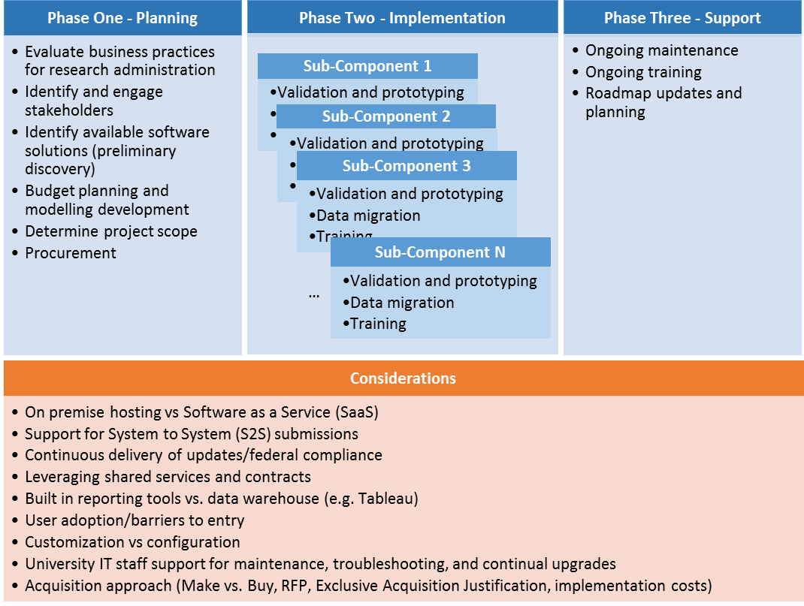

Given the complexity of this project and all of the dependencies on other systems and personnel throughout the UT Austin campus and the state, the Operating Sponsors will be responsible for prioritizing the phases that will be in scope. During the first phase, the Operating Sponsors will review all efforts underway and in the pipeline for the future.

Project Objectives

The main objective of the RMS Project is to enable primary stakeholders (e.g. faculty, departmental staff) of the University to more efficiently and effectively access and use information from the research enterprise systems.

The long-term goals of the project include:

- Improve our ability to collect, store, analyze, and share data enabling us to report information about our research enterprise to improve collaboration, proposal preparation and strategic decision making;
- Reduce the compliance and administrative burden of our faculty, department, school and central institutional staff;
- Improved usability of the research enterprise by providing consistent, intuitive, and concise look and feel for the stakeholders;
- Provide integrated systems reducing the number of systems to log into, eliminating multiple data entry, reducing IT burden, and reducing overall transaction processing time;
- Reduction in paper form processing and retention;
- Improved research data transactional searching and reporting;
- Reduction in the number of shadow/supplemental systems across campus by meeting needs through central systems when feasible;
- Implement a comprehensive, searchable database of research activity on the UT campus; and
- Support automation for verifying compliance with sponsor regulations and for identifying collaboration opportunities among faculty.

The RMS Project is not necessarily intended to immediately meet the needs of all who are intended to benefit from it. The scope of the first phase of the project is limited and focused on defining the project scope, procurement and implementation, and further phases of the project could encompass any or all research-related processes on campus as part of the overall RMS Replacement.

Project Scope

When the current in-house developed RMS was launched in 1998, there were no comprehensive “off the shelf” grants administration or compliance systems. Today, there are viable options for implementing solutions that could deliver most, if not all, of the functionality required to manage grants and compliance at the University. Solutions can also be highly customized to meet institutional needs and required business processes. An effective electronic research administration system will:
- Maintain effective communication with sponsors;
- Position the University to be more competitive in research and discovery;
- Continually improve research support infrastructure;
- Meet the demands of increased research growth;
- Help ensure compliance with regulatory agencies and COI Rules; and
- Reduce burden on faculty and central and departmental staff.

Priorities and projects will be determined by the operational sponsors in consultation with various campus stakeholders, advisory groups, and the project team. Examples of the groups that the operational sponsors will seek input from include:

- Principle Investigators (PIs)
- College and departmental leadership with varying perspectives and levels of impact
- Senior university officials
- College and departmental and central research support staff

Phase one (lasting through Fall 2018) will focus on the following items:

- Development of a comprehensive strategy for the RMS Replacement project.
- Development of guiding principles for the project.
- Identification of problematic areas in the current research enterprise system.
- Identification and specification of the RMS Replacement project deliverables.
- Documentation of existing and objective business processes and plan for future procurement of the RMS Replacement.
- Identify the implementation plan for subsequent phases of the project based on the approved project scope defined by the sponsors and project leadership.

The components that are potentially within the RMS Replacement project scope are listed within the below diagram. A final decision of what is in scope and what is out of scope will be made at the end of phase one.

Components outside of the scope diagram area reflect the integration points with other institutional systems that exist with the research administration systems today.
​
Diagram of Potential In Scope

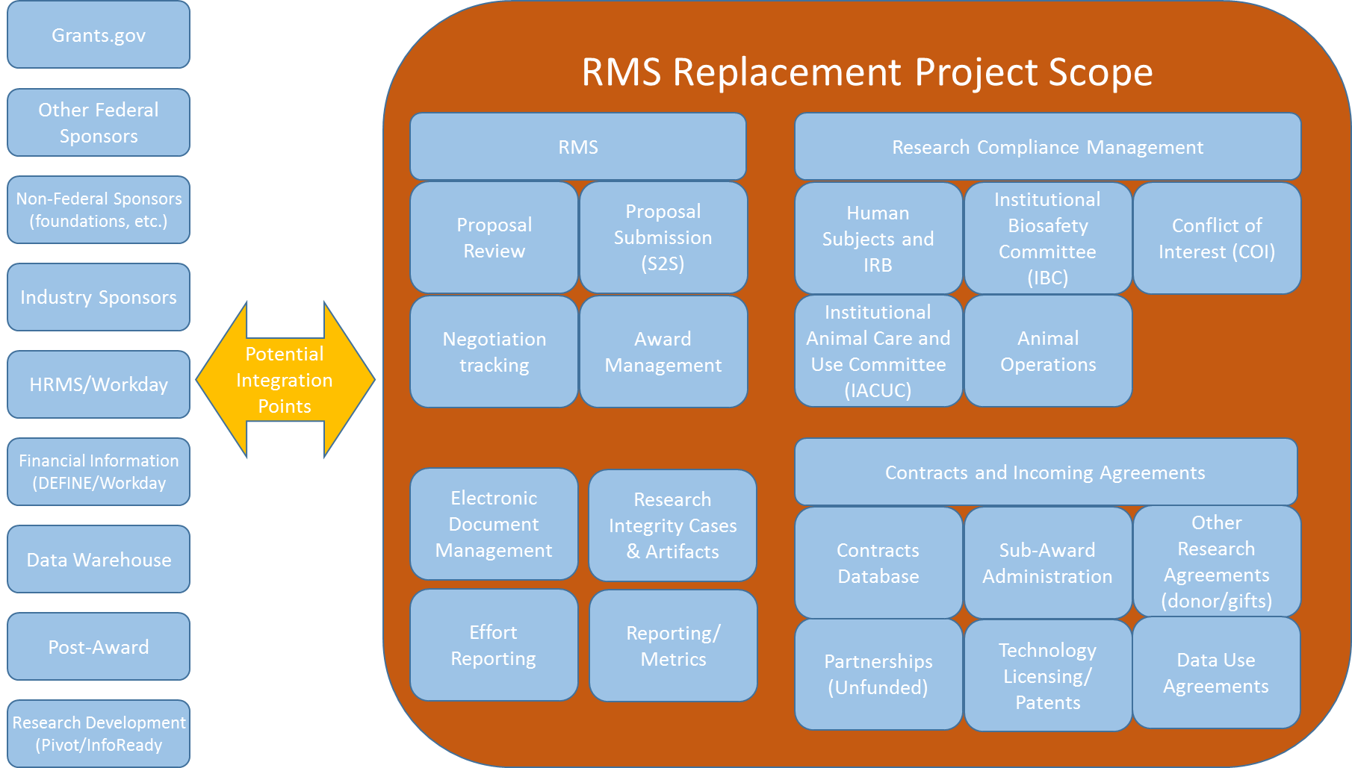

Project Schedule

February 2018
- RMS Replacement Project planning (phase one) begins

March – June 2018
- Peer institution discovery period
- Vendor engagement and discussions
- Business process capture and modelling

July 2018
- RFI/RFQ issued
- Budget model development

August 2018
- Vendor responses received and evaluated
- Site visits to peer institutions

September 2018
- Stakeholder Town Halls
- Project scope and procurement decision

Q4 2018
- Vendor acquisition activities
- Complete project planning

Q1 2019
- RMS Replacement Project Implementation phases begin

Subproject Deliverables

Regardless of the phase, the following standard deliverables will be produced during the RMS Replacement project:

- Process Diagrams – These should be done by business experts from a process standpoint. They should document attributes, relationships, field names, indexes, keys, filters, etc.
- Standards/Definitions – This data will provide for consistency, maintainability and repeatability in the project (or others to follow) and define what is meant by certain key terms.
- Testing Results – This will include the testing plans and critical thresholds that were tested to ensure the highest quality and attainment of phase objectives for system functionality and stakeholder delight.
- Communication/Training Documentation – This will include a plan and curriculum to address the various user groups’ needs and perspectives.
- Metrics – Metrics will be defined and monitored so that efficiencies that are expected can be monitored, increasing the opportunities for them to be achieved.
- Usability, Focus Group and User Feedback – This will include a plan for and documentation of how project decisions are made and vetted through stakeholders in order to ensure the system meets the needs of the various user groups’ needs and perspectives. Where possible, decisions will be supported by metrics.
- Detailed Project Plans – A detailed project plan that outlines milestones and contingency plans.
- Benefits and Return on Investment documentation – Every subproject of the RMS Replacement will have an associated benefits and ROI document that will be developed early in each subproject. Baseline metrics will be gathered for later analysis of impact as well as documentation of expected changes to campus.

Constraints and Expectations

The RMS Replacement project will not be successfully implemented unless the following Critical Success Factors are achieved:

- Knowledgeable, Decisive Leadership – Without trusted and empowered leadership, progress will be slow and benefits achieved will be marginal at best.
- Appropriate Governance –The governance structure should be established such that it is characterized by a clear mission, defined scope, appropriate stakeholders, and commonly embraced values. An important aspect of the governance structure is the requirement that the business needs drive the deployment of the university ERP with the support of key partners such as IT and user support services (such as training and communication). (See Appendix C)
- Shared Vision – If the university leadership collectively agrees to a shared vision for the university ERP and how it can best support the mission of the university, all aspects of the deployment of the university ERP will be made easier. The vision should be clearly communicated to ensure that while the ultimate vision for the project is shared and known, it is also clear that the deployment of the first phase of Financial Resource Management System will not achieve the ultimate vision of the project but that subsequent phases will be undertaken to achieve this vision over the course of several years.
- Environment – By fostering an environment that is characterized by teamwork and collaboration, success will be easier to achieve. Improved support, training, documentation, communication, user involvement, business process transparency and support for lifelong learning will help create an environment to attain the maximum success possible.
- People – To achieve the strategies in this plan, the most talented staff will be required to be committed to these efforts for many years. A commitment to the people resources required for each phase should be achieved prior to each phase beginning.
- Adequate Funding –Additional resources and a realignment of current resources will also be required with plans and methods to harvest the expected return on this investment. A commitment to the funding required for each phase should be achieved prior to each phase beginning and be appropriately allocated to each member institution benefiting from the administrative system.
- Time – Regardless of the financial and human resources provided, a significant amount of time will also need to be invested. Wisely balancing the need to complete and implement solutions in a timely manner with the risk of a poor implementation or a poor solution is critical. A detailed project plan that is developed prior to each phase beginning as well as following an iterative development methodology will assist in the project being on time.
- Technical Infrastructure – Maintenance and deployment of administrative software cannot succeed without stable, dependable, high-performing, scalable and secure technical infrastructure.
- Assessment – Responsible stewardship demands periodic assessment to determine if the chosen course continues to be the best course of action given changes in industry, product availability and success of the university ERP. The definition of success should be defined before the project is started and should be measurable.

Constraints
As the project progresses, the following (internal or external) constraints could be encountered:
- Budget limitations and availability
- Time limitations
- Resource availability
- Timely skill set availability
- University or School policies
- Unexpected federal mandates

Dependencies
- Vendor Recommendations
  - The order of implementing the modules
  - Recommended time line for implementation
  - Recommendation for professional services (internal or external resources)
- Internal
  - Interfaces with existing systems and resource availability
  - Business owner of application interface considering PAAMCO a priority
  - Business cycle activities relative to implementation target dates
  - Timely hardware acquisition and installation

Project Governance

Project governance will follow the administrative software systems strategic plan governance model.

Stakeholders/Team members
See Appendix A: RMS Replacement Project Stakeholders and Team Members

Project Organization Chart

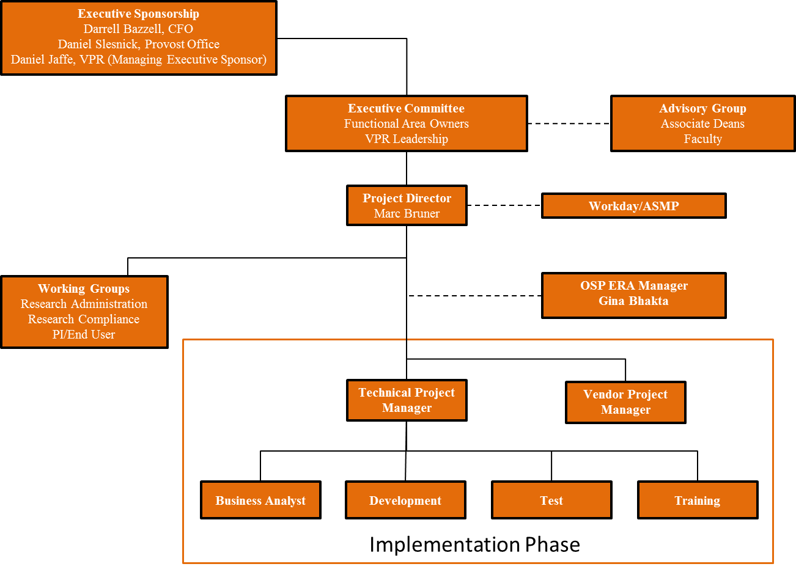

Roles and Responsibilities

Role | Purpose | Responsibilities
Executive Sponsor | Provides high-level strategic direction on the project, cascade project sponsorship throughout the University, and resolve resource and budget constraints | - Meet with the Operational Sponsors and Project Managers quarterly to receive an update on project status and resolve outstanding issues, in particular those related to resources.  - Review the strategic direction of the project and adjust as appropriate to ensure that the project remains in line with University goals and objectives.
Operational Sponsors/Executive Committee | Establish project objectives and deliverables, determine project priorities, provide tactical project direction to the project and resolve and act as a final decision point for any issues, including questions of policy that cannot be resolved by the Project Team | - Meet bi-weekly with the Project Director to monitor project progress, review deliverable status, resolve issues as appropriate and ensure that timelines are being met.  - The scope of any established objectives and policies developed by the Operational Sponsors will operate within the strategic direction established by the Executive Sponsors.
Advisory Group | Provide broad-based advisement to the Operation Sponsors and project team related to the project | - This group will be made up of representatives from the portfolios and/or their departments as each portfolio sees fit to be included.
Project Director | Direct and manage project work | - Responsible for ensuring that the Project Team completes the project; responsible for management of project process  - Develops Project Charter and comprehensive project plan via joint planning with the Technical Lead and other members of the Project Team  - Coordinates and manages the team’s performance of project tasks, ensuring integration of all project work with focus on creation of project deliverables and work performance information  - Secures acceptance and approval of deliverables from the Project Sponsor, Steering Committee and Stakeholders  - Responsible for communication including status of project health  - Responsible for risk management, and escalation of issues that cannot be resolved in the team  - Responsible for managing change requests and documenting decisions made by accountable parties: sponsor, advisory committee, Technical Lead, Enterprise Architecture, Information Security, etc.  - Manages project procurements working with Resource Management  - Ensures project is delivered within budget, on schedule and within scope
Project Team |  | - Manage all day-to-day aspects of the Research Management System Replacement project, including project plans, deliverables, status reviews, milestone reviews and project team member activities.
Core Team |  | - Includes all resources who provide labor to create the deliverables of the project  - May include members of functional business departments, external entities (vendors), IT resources, customers, etc.
Extended Team Stakeholders | The “liaisons” assuring representation | - Collects, communicates and represents the interests of the larger stakeholder community to the Advisory Committee  - Shares and updates their stakeholder community on the status of the project and the deliberations and decisions of the Advisory Committee  - Recommends education and communication strategies expected to most benefit the stakeholder community

Communication Plan

This communication plan will be used as a template but refined for each project phase to ensure communication is best suited for the unique needs for each phase of the RMS Replacement project. After each phase, the communication plan will be assessed and changed as needed based on lessons learned.

In order to ensure widespread communication regarding the RMS Replacement Project, the following medium will be used:

- Website – The RMS Replacement project website will contain general information about the project status, system availability, and contact information.
- Status Reports – In order to provide regular updates to stakeholders, the Advisory Group, Operational and Executive Sponsors, status reporting will take place at regular intervals. These reports will be placed on the RMS Replacement web page so that all interested parties can review them.
- Advisory Group – Provide important feedback to the project from a cross-campus decision-making perspective. This group is made up of decision makers from across the campus. This group will meet monthly.
- Monthly in person update to research administration community - Monthly updates to the research administration network group to spread knowledge about the system and inform them about important dates and activities (i.e. training).
- Special RMS Replacement User Groups – It may be necessary to establish subject-area-specific user groups. The purpose of these groups is to obtain feedback from experts in existing or new processes relating to their specific area of expertise or responsibility. Additionally, the user groups will be responsible for providing suggestions on complex reports and additional data requirements back to the project team, plus assist in evaluating and improving features and the design of the overall system.
- E-Mail Bulletins – These will be done on an ad hoc basis to various user groups established for the project.
- Project Team – The RMS core project team (those individuals who report to the Project Director) will meet regularly for both status updates and collaborative work sessions.

Status update meetings will be kept to a minimum, and most of the status update information will be exchanged via e-mail or web site updates. Collaboration work sessions will be held frequently to make sure all project team members are working in harmony. Between work sessions, project team members will be encouraged to speak to other team members about the project in person when possible (preferable), via phone or web meeting when in-person is not possible, and via e-mail as a last resort. This will require that project team members make an extra effort to see each other and find opportunities to work in labs or war room environments.

Project Quality Plan

One of the important roles on the RMS Replacement project during the implementation phase is a Quality Assurance (QA) Coordinator. The QA coordinator and all those who work on the QA team will have responsibility for all quality reviews.

After each project milestone (i.e. major project deliverable within a phase), the QA Coordinator will be asked to conduct a final quality review with their team. If the deliverable is acceptable, then the QA Coordinator will sign off that the milestone is complete. The reason for this review is to ensure that each deliverable works as expected and quality software is deployed.

The QA Coordinator will be responsible for defining the QA methodology for the project to include incident tracking and response system and processes, test plans and checklists.

Quality reviews at project milestones will be accepted based on the following criteria:

- Software performs as expected.
- Data changed by the software results in accurate updates to the database.
- Integration points between the RMS Replacement and other areas are working properly (to be coordinated with QA specialists in the area RMS is integrating with).
- The file and software design supports efficient processing (load time for the initial screen and subsequent update screens are within user-defined acceptable limits).
- Feature/functionality being tested has been through stakeholder usability testing, focus group or feedback or in some way has been vetted through the stakeholder of the feature or function.

Training Plan

To optimize the stakeholder acceptance of the ultimate RMS Replacement deployment, training should begin early, occur often, and be conducted using a variety of training methods.

During the implementation phase, a Training Coordinator will be responsible for developing a detailed training plan for the project.

Some of the types of training to be included in the detailed plan will be:
- Awareness of concepts, features to expect and differences in business processes
- Introductory training for research administrators and approvers
- Training individuals within units who can provide initial training to faculty and staff
- Specialized training for
  - Faculty-heavy colleges
  - Large colleges
  - Small colleges
  - Administrative departments
- Hands-on training to assist people in accomplishing tasks using the new system (e.g. open labs)

The training plan will also consider the training burden for stakeholders, especially for PIs and infrequent users that will interact with the system only occasionally.

Some specific methods to be employed include:
- Classroom instruction
- Workshops
- Q&A sessions
- Online videos and web-casts
- Product manuals and documentation of frequently encountered scenarios
- Online and inline help and FAQs
- One-on-one where needed

Initial Risk and Mitigation Plan

Risks are inherent in any project. As a result, risk logs and mitigation plans are maintained throughout the life of a project to ensure that plans are in place to minimize project impact. The RMS Replacement project is potentially broad in scope and will enact changes in the research enterprise for a large user base – over 2700 PIs, research administrators, and central staff at UT Austin. At the onset of the project, the following risks have been identified:

Risk | Mitigation
Lack of preparedness or ability of dependent software systems (or resources who maintain these systems) to provide necessary integration or functionality. This includes dependencies on infrastructure hardware and software that will be required in order for RMS Replacement project to be deployed successfully. | - Break project into phases that are designed and planned in detail such that dependent areas have time to prepare to meet the needs of the RMS Replacement.  - Documentation of dependencies.  - Communicate frequently with dependent areas so they know the status of the project and when the project needs their changes to be in place and the project knows in advance if the changes will not be in place
Inability to make planned milestones and targets | - Highly developed project plan  - Frequent monitoring of progress and risk plan.  - Put in place a prioritized feature list so that if the project or phase needs to be scaled back, it is easy to do.  - Project governance structure  - Critical path decision process
Project is not staffed appropriately with the right number of people or people who do not have the talents, experience, and skills required for the project. This may lead to impaired or failed deployment. | - Before each phase of the project begins, the Executive and Operational Sponsors will receive a resource plan for the phase and appropriate resources should be allocated prior to any work beginning.  - If there are significant losses to the project that result in staffing problems, the Project Director will work with the sponsor groups to determine if the project can continue and be successful.
Sponsor groups do not share a common vision for the project or support the project as a team as is required for a project of this size and complexity. | - The charter is used as the basis for the project to which all sponsors agree to use  - Sponsors agree to work in concert with the Project Director to come to agreement on any issues that need resolution.
“Go live” date becomes more important as a driver than quality deployment | - Use of QA Coordinator to determine if system is of sufficient quality to be deployed  - Sponsors have ultimate decision on “Go Live” dates
Failure to realize and harvest expected returns on investment in software development and workflow changes. | - Detailed quantifying of benefits by comparing resource processing requirements for current environment versus those that will be required with new system.  - Commitment of project personnel to follow up and monitor user acceptance to ensure desired results are attained.
System does not meet the needs of the colleges and university. | - Have participation from the Colleges and departments on the Operational Sponsor group and stakeholder advisory groups.  - Make use of focus groups, usability groups, stakeholder surveys, and data documenting current behavior.  - Reduced transactions/volumes and process  - Communications planning  - Training plans  - User manuals and materials  - Commitment of project staff until some predetermined date after implementation to ensure adequate support of new system.
Conflicting internal and external projects (e.g. Workday migration, etc.) that may affect financial data or project staff. | - Sponsors agree to work in concert with the Project Director to come to agreement on any issues that need resolution.
Changes in the institutional mission and objectives as a result of economic, political, environmental, etc. factors | - Sponsors agree to work in concert with the Project Director to come to agreement on any issues that need resolution.

Throughout the life of the project, risks in addition to those listed above will be identified. Each identified risk and corresponding mitigation plan will be documented in a project log and reviewed with Project Sponsors on a bi-monthly basis. Any risks that have potential wide-spread impact will be reviewed with the Executive Sponsor during quarterly meetings.

Change Management

The purpose of change management is to define and implement procedures and/or technologies to deal with changes in the business environment and to benefit from changes. Successful adaptation to change is as crucial within an organization.

For the RMS Replacement project, all changes to the software, business processes, and the like will be documented to ensure proper tracking.

